**Hands-on .NetCore 3.0**

**Displaying Color Text**

Table of Contents

Scaffolding Console App Basics 2

Different Color Text In Console 2

Creating the console app 2

Program.cs Changes 2

Simulation 3

# Scaffolding Console App Basics

We have already run the commands multiple times, here is the info

* dotnet new console
* dotnet restore [pulls in the dependencies needed by the application]
* dotnet run [compiles and run the application]
* dotnet build [compiles the application]
* dotnet publish [packages up the files for reuse]

Take a look at this document for more details:

<https://itplate.blogspot.com/2019/11/scaffolding-applications-with-net-cli.html>

# Different Color Text In Console

## Creating the console app

Run command **dotnet new console -o ColorText**

It has done the restore for us as well

Open the app with VS Code by

1. **cd ColorText**
2. and then typing **code .** [code space dot]

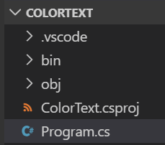

## Program.cs Changes

Change the console forground color and then add then display a new text

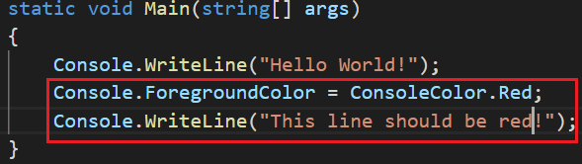

Perform **dotnet run**



Important thing to note is to change the color back to white or the command line sessions after that will always be red or till we close the application.

## Simulation

We’ll put different color for different debug messages. Lets change the program.cs to

Rather than writing the same piece of code again and again, we have written a function and passing the message and its color.

Take a look at the percentage and sin lines. These are using formats to display the info as we want it to display. Also look at the other formats as well and then play with date formats on your own.

The function is receiving a nullable color, so using **GetValueOrDefault()** with it.

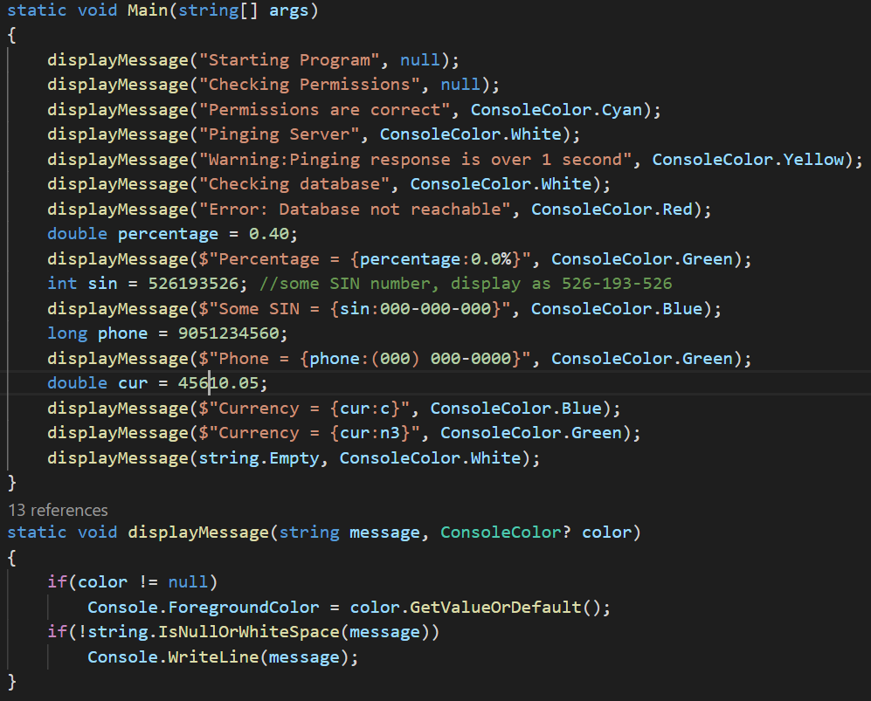

Run it by typing **dotnet run**

